**Bahria University, Lahore Campus**

Department of Computer Sciences

Lab Journal 11

**(Fall 2023)**

|  |  |  |
| --- | --- | --- |
| Course: | **Digital Communication Network Lab** | Date: 14-12-2023 |
| Course Code: | CSL-320 | Max Marks: 20 |
| Faculty’s Name: | Dawood Akram | Lab Engineer: Muhammad Umar Nasir |

Name: _____________________________ Enroll No: _______________________

## Objective(s):

To implement Dynamic Host Configuration Protocol and Domain Name Services on packet tracer.

## Tool(s) used:

CISCO Packet tracer

Internet Service Providers (ISPs) usually use DHCP to allow customers to join the Internet with minimum effort. The DHCP server maintains a database of available IP addresses and configuration information. When it receives a request from a client, the DHCP server determines the network to which the DHCP client is connected, and then allocates an IP address. DHCP servers typically grant IP addresses to clients only for a limited interval.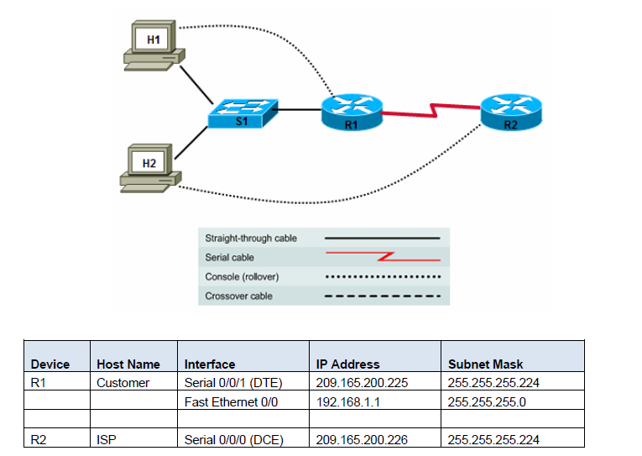 DHCP was created by the Dynamic Host Configuration Working Group of the Internet Engineering Task Force (IETF; a volunteer organization which defines protocols for use on the Internet). As such, it's definition is recorded in an Internet RFC and

the Internet Activities Board (IAB) is asserting its status as to Internet Standardization. As of this writing (June 1998), DHCP is an Internet Draft Standard Protocol and is Elective. BOOTP is an Internet Draft Standard Protocol and is recommended. For more information on Internet standardization, see RFC2300 (May 1998) DHCP is based on BOOTP and maintains some backward compatibility. The main difference is that BOOTP was designed for manual pre-configuration of the host information in a server database, while DHCP allows for dynamic allocation of network addresses and configurations to newly attached hosts. Additionally, DHCP allows for recovery and reallocation of network addresses through a leasing mechanism. RARP is a protocol used by Sun and other vendors that allows a computer to find out its own IP number, which is one of the protocol parameters typically passed to the client system by DHCP or BOOTP. RARP doesn't support other parameters and using it, a server can only serve a single LAN. DHCP and BOOTP are designed so they can be routed

**Step 1: Restart the Customer router to remove the DHCP commands added by SDM.**

a. Because you did not save the DHCP configuration created using SDM to NVRAM, restarting the router restores the basic configuration created in Task 1, Step 2. On the Customer router, issue the **reload** command.

b. When prompted to save the configuration, respond with **no**.

c. When prompted with **Proceed with reload? [confirm]**, press **Enter**.

d. Press Enter at the **Press RETURN to get started!** prompt. You should now see the **Customer>** prompt.

**Step 2: Check the host DHCP client H2 IP configuration.**

a. Open a command prompt window on H2 and issue the **ipconfig /release** and **ipconfig /renew** commands. Because there is no DHCP server currently configured, it may take a while to timeout.

b. At the command prompt, now issue the **ipconfig** command. What is the IP address and subnet mask for H2? ____________________________________________________________________________

**Step 3: Configure the DHCP server excluded addresses on the Customer router.**

To prevent certain addresses from being assigned they must be excluded from the pool. This includes the IP address of the router Fast Ethernet 0/0 interface (the default gateway). In this lab, also exclude addresses from 192.168.1.101 through 192.168.1.254 to reserve them for other purposes, such as servers and printers, which need to have a fixed IP address.

a. To exclude addresses, issue the **ip dhcp excluded-address** command.

Customer(config)#**ip dhcp excluded-address 192.168.1.1**

Customer(config)#**ip dhcp excluded-address 192.168.1.101 192.168.1.254**

b. Why do you want to exclude addresses before the DHCP pool is even created?

_______________________________________________________________________

_______________________________________________________________________

**Step 4: Configure the DHCP pool.**

On the Customer router, configure a DHCP pool for the internal clients.

Customer(config)#**ip dhcp pool INTERNAL**

Customer(dhcp-config)#**network 192.168.1.0 255.255.255.0**

Customer(dhcp-config)#**domain-name abc-widgets.inc**

Customer(dhcp-config)#**default-router 192.168.1.1**

Customer(dhcp-config)#**dns-server 192.168.1.200**

**Step 5: Test the DHCP pool for H2.**

a. On H2, open a command prompt and issue the **ipconfig /release** and **ipconfig /renew** commands.

b. On H2, issue the **ipconfig /all** command.

c. What IP address is issued to H2? __________________________

d. What is the subnet mask of H2? __________________________.

e. What is the default gateway of H2? __________________________

f. What is the connection-specific DNS suffix (domain name) of host H2? ________________________

g. What is the DHCP server IP address? __________________________

h. What is the DNS server IP address? __________________________

i. What is the MAC address of H2? ____________________________

j. From H2, ping the default gateway (the router Ethernet interface). Does the ping succeed? _______

Troubleshoot as necessary, and do not proceed until the ping is successful.

**Step 6: Test the DHCP pool for H1.**

a. On H1, choose **Start > Settings > Control Panel > Network Connections > Local Area Connection** and change the IP configuration from static to dynamic to make H1 a DHCP client like host H2. Click the **Properties** button, and then click **Internet Protocol (TCP/IP) Properties**. Select **Obtain an IP address automatically** and **Obtain a DNS server address automatically**. Click **OK** to exit the configuration window.

b. Open a command prompt on H1 and issue the **ipconfig /release** and **ipconfig /renew** commands. Because there is no DHCP server currently configured, it may take a while to timeout.

c. At the command prompt, now issue the **ipconfig** command.

d. What IP address is issued to H1? __________________________

**Step 7: Display the DHCP binding on the Customer router.**

a. To see the IP address and host hardware (MAC) address combination assigned by the DHCP server, issue the **show ip dhcp binding** command on the Customer router.

Customer#**show ip dhcp binding**

IP address Client-ID/ Lease expiration Type

Hardware address

192.168.1.2 0100.0bdb.04a5.cd Feb 22 2008 11:19 AM Automatic

192.168.1.3 0100.07e9.63ce.53 Feb 22 2008 11:27 AM Automatic

b. Do the hardware addresses displayed match those recorded for hosts H1 and H2 in Task 1, Step 1? ______

c. On the Customer router, display the characteristics of the DHCP pool using the **show ip dhcp pool** command**.**

Customer#**show ip dhcp pool**

Pool INTERNAL :

Utilization mark (high/low) : 100 / 0

Subnet size (first/next) : 0 / 0

Total addresses : 254

Leased addresses : 2

Pending event : none

1 subnet is currently in the pool :

Current index IP address range Leased addresses

192.168.1.4 192.168.1.1 - 192.168.1.254 2

d. How many addresses have been leased? ______

e. In the output from the command, what do you think **Current Index** means?